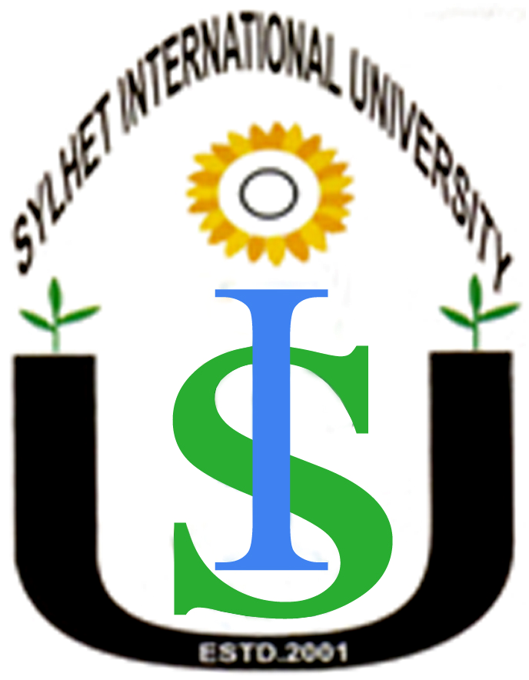
Sylhet International University
Faculty (Full Time Teachers) 2014

Teachers Name (Business Administration) |  | Designation
1 | Mr. Kamrul Hasan, BBA, MBA (RU) | Asst. Professor
2 | Mr. Md. Mahedi Hasan Tuhin, BBA, MBA (DU) | Asst. Professor
3 | Ms. Nayeema Maswood, BBA, MBA (RU) | Asst. Professor
4 | Mr. Mohammad Rezaul Kabir, B BA, MBA (RU) | Asst. Professor
5 | Ms. Bilkis Akther, BBA, MBA. (RU) | Asst. Professor
6 | Ms. Shahida Khanam, BBA, MBA (SIU) | Asst. Professor
7 | Mr. Abu Syeed Muh. Abdullah, BBA,MBA,(SUST) | Asst. Professor
8 | Ms. Aysha Yasmin,BBA, MBA (SUST) | Asst. Professor
9 | Mr. S.M. Saief Uddin Ahmed, BBA,MBA (DU) | Asst. Professor
10 | Mr. Mohammad Mohiuddin , BBA(SUST),MBA(UK) | Lecturer
11 | Mr. H.M. Arif, BBA, MBA (DU) | Lecturer
12 | Mr. Md. Mohsin Hossain, BBA, MBA (DU) PGD (UK) | Lecturer
13 | Ms. Kowser Jannat, BBA, MBA(CU) | Lecturer
14 | Ms. Touheda Yasmin Chowdhury, BBA(SIU) | Lecturer
15 | Mr. Pronab Kumar Saha , BBA, MBA (CU) | Lecturer
16 | Mr. Md. Hasan Al – Maruf, BBA, MBA (SUST) | Lecturer
17 | Mr. Shirshendu Chakrabarty, BBA (LU), MBA (AIUB) | Lecturer
18 | Ms. Kamrun Naher, MBA, BBA (RU) | Lecturer
19 | Ms. Shamima Yeasmin, BBA, MBA (DU) | Lecturer
20 | Ms. Nasrin Nahar, BBA, MBA (SUST) | Lecturer
21 | Mr. Neser Ahmed, BBA, MBA (DU) | Lecturer

Teachers Name (Department of English) |  | Designation
22 | Mr. Md. Jakaria Habib, BA (Hons.) MA (RU) | Asst Professor
23 | Mr. Md. Mohabbat Hossain, BA (Hons.) MA (P U, India) | Asst. Professor
24 | Mr. Muhd. Mustafizur Rahman, BA (Hons.) MA (IU) | Asst. Professor
25 | Mr. Syed Hasan Mahmud, BA (Hons), MA (KU) | Asst. Professor
26 | Mr. Ziaul Haque, BA (Hons), MA (SUST) | Lecturer
27 | Mr. Ashraful Hassan,BA (Hons), MA (DU) | Lecturer
28 | Mr. Md. Nurul Hasan Razib, BA (Hons), MA(SIU) | Lecturer
29 | Ms. Mamata Hena Wahid, BA(Hons.), MA(SUST) | Lecturer
30 | Mr. Pranab Kanti Deb, BA (Hons) (NU), MA (SIU) | Lecturer
31 | Ms. Saimun Afrozee, BA (Hons.), MA (SUST) | Lecturer
32 | Ms. Joysree Deb, BA (Hons.), MA (SUST) | Lecturer
33 | Ms. Swati Rani Debnath, BA (Hons), MA (SUST) | Lecturer
34 | Ms. Farzana Akhanjee, BSS, MSS (SUST), DMS( ICL) | Lecturer
35 | Ms.Humayra Rahman Suma, BSS, MSS (SUST) | Lecturer
36 | Ms. Jebin Sultana Chowdhury, BSS, MSS (SUST) | Lecturer

Teachers Name (CSE) |  | Designation
37 | Mr. Khaled Hussain, B Sc Engg. (CSE), M Sc (UK) | Assistant Professor
38 | Mr. Abdul Awal Ansary, B Sc Engg.,M.Phil (Fellow) (CSE) SUST | Assistant Professor
39 | Ms. Subarna Sarker Rupa, B Sc .M.Sc (SUST) | Assistant Professor
40 | Mr. Rajarshi Roy Chowdhury, B.Sc Engg. (UOW), M.Sc.(USM) | Lecturer
41 | Ms. Marium – E- Jannat BSc Engg .M.Sc (SUST) | Lecturer
42 | Mr. Tasnim Haider Chaudhury, B.Sc Engg. (SUST) | Lecturer
43 | Ms. Farida Yeasmin BSc Engg (SUST) | Lecturer

Teachers Name ( ECE) |  | Designation
44 | Mr. Khandaker Dahirul Islam, B Sc Engg. (KU)  M Sc Engg (AEM) BUET | Asst. Professor
45 | Mr. Shahjahan Ahmed, B Sc Engg. (ECE) SIU. | Asst. Professor
46 | Mr. Balayet Hussain, B.Sc Engg. (KUET | Lecturer
47 | Mr. Muzibul Kamal, B.Sc Engg. (KUET) | Lecturer
48 | Mr. Md. Mahmudul Alam Mia , B. Sc. Engg (KU), M.Sc.Engg.(University of Leicester, UK) | Lecturer
49 | Mr. Md. Shahnur Alam, B.Sc, M.Sc (APE.CE) DU | Lecturer
50 | Mr. Ferdous Wahid, BSc Engg (ECE) KUET | Lecturer

Teachers Name (Law) |  | Designation
51 | Ms. Taslima Sultana, LL B(Hons.), LL M (IU) | Asst. Professor
52 | Mr. Mahmudul Hasan Khan, LL B (Hons) LL M (RU) | Asst. Professor
53 | Mr. Mehdi Hasan, LL B (Hons) LL M (IU) | Asst. Professor
54 | Mr. Md Arafat Hussain, LL B (Hons) LL M (RU) | Asst. Professor
55 | Mr. Md. Moshiur Rahman, LLB(Hons), LLM (IU) | Asst. Professor
56 | Mr. Md. Humayun Kabir, LL B (Hons.) LL M (DU) | Asst. Professor
57 | Mr. A.K.M. Sohel Habib Nowroz, LLB (Hons), LLM | Lecturer
58 | Mr. Md. Nazmul Ahad, LLB(Hons), LLM (IU) | Lecturer
59 | Mr. Saruar Ahmed, LLB(Hons), LLM (SIU) | Lecturer
60 | Mr. Mohammad Sharifuzzaman, LLB, LLM (DU) | Lecturer
61 | Mr. Samiur Rashid Chowdhury, LLB, LLM (SIU) | Lecturer
62 | Mr. Md. Abul Bashar, LLB, LLM (DU) | Lecturer
63 | Mr. Md.Asaduzzaman Khan, LLB, LLM (DU) | Lecturer
64 | Mr. Md. Sabbir Ahsan, LLB, LLM (RU) | Lecturer
65 | Mr.Milan Chandra Pal, LLB, LLM (DU) | Lecturer
66 | Mr.Md. Masum Billah, LLB, LLM (DU) | Lecturer
67 | Mr. Anupom Ghope, LLB, LLM (SIU) | Teaching Assistant

